|  |  |  |
| --- | --- | --- |
|  | **SRI KRISHNA COLLEGE OF TECHNOLOGY**  [An Autonomous Institution | Affiliated to Anna University and  Approved by AICTE | Accredited by NAAC with ‘A’ Grade]  KOVAIPUDUR, COIMBATORE – 641 042.  **DEPARTMENT OF COMPUTER SCIENCE AND ENGINEERING**  **21ITE07 – Web Technologies**  HTML & CSS3 | Java | Javascript  **Lab Manual** | Description: New LOGO SMALL Size |

|  |  |  |  |  |  |
| --- | --- | --- | --- | --- | --- |
|  | | **SRI KRISHNA COLLEGE OF TECHNOLOGY**  [An Autonomous Institution | Affiliated to Anna University and  Approved by AICTE | Accredited by NAAC with ‘A’ Grade]  KOVAIPUDUR, COIMBATORE – 641 042. | | Description: New LOGO SMALL Size | |
| **Course Outcomes**:   |  |  |  | | --- | --- | --- | | CO1 | Outline the internet standards and recent web technologies like conferencing, newsgroup etc. | [U] | | CO2 | Develop static and dynamic web pages using basic web concepts. | [AP] | | CO3 | Apply the knowledge of HTML and CSS code to create personal and/or business websites following current professional and/or industry standards. | [AP] | | CO4 | Develop a web-based information systems using HTML, XML. | [AP] | | CO5 | Apply dynamic web page design techniques to construct an interactive web page using client-side technologies. | [U] | | CO6 | Construct server-side scripts using JSP and Servlets for web applications. | [AP] | | | | | | |
| **Sl.No** | **List of Experiments** | | **CO Mapping** | |
|  | Create a web page with the following using HTML.  • To embed an image map in a web page.  • To fix the hot spots.  • Show all the related information when the hot spots are clicked. | | CO2 | |
|  | Create a web page with all types of Cascading style sheets | | CO3 | |
|  | Client Side Scripts for Validating Web FormControls using DHTML | | CO5 | |
|  | Write programs in Java using Servlets:  ● To invoke servlets from HTML forms.  ● Session Tracking. | | CO6 | |
|  | Write programs in Java to create three-tierapplications using JSP and Databases  ● For conducting on-line examination.  ● For displaying student mark list. Assumethat student information is available in adatabase which has been stored in adatabase server | | CO6 | |
|  | Programs using XML – Schema – XSLT/XSL | | CO4 | |
|  | Programs using NoSQL | | CO4 | |

**Ex:1 Creating A Webpage Using Image Map**

**AIM:** To Create a web page with the following using HTML

i) To embed an image map in a web page

ii) To fix the hot spots

iii) Show all the related information when the hot spots are clicked.

**Algorithm**

Step1: Open a notepad.

Step 2: Write the code for imagemap.html.

Step 3: Enter a program that includes tags for <MAP> and other tags.

Step 4: Insert Hyperlink using <A href>.

Step 5: Save the file with .html extension.

Step 6: Run the program in a web browser

Step 7: Display Results.

CODE:

**CODE:**

<html>

<head>

<title>ImageMap</title>

</head>

<body>

<center>

<style>

body {

background-image: linear-gradient(rgba(0,0,0,0.2),rgba(0,0,0,0.2)),url(indiaflag.jpg);

}

</style>

<br>

<h1><p style="color: NAVAJOWHITE">CLICK ON THE NAME TO KNOW ABOUT THAT PLACE</h1>

<img src="india.gif" usemap="#indiamap" >

<map name="indiamap">

**CODE:**

<html>

<head>

<title>ImageMap</title>

</head>

<body>

<center>

<style>

body {

background-image: linear-gradient(rgba(0,0,0,0.2),rgba(0,0,0,0.2)),url(indiaflag.jpg);

}

</style>

<br>

<h1><p style="color: NAVAJOWHITE">CLICK ON THE NAME TO KNOW ABOUT THAT PLACE</h1>

<img src="india.gif" usemap="#indiamap" >

<map name="indiamap">

<area shape="rect" coords="206,47,339,100" href="https://en.wikipedia.org/wiki/Ladakh" title="Ladakh">

<area shape="rect" coords="212,392,350,472" href="https://en.wikipedia.org/wiki/Madhya_Pradesh" title="Madhya Pradesh">

<area shape="rect" coords="94,282,237,360" href="https://en.wikipedia.org/wiki/Rajasthan" title="Rajasthan">

<area shape="rect" coords="267,275,409,348" href="https://en.wikipedia.org/wiki/Uttar_Pradesh" title="Uttar Pradesh">

<area shape="rect" coords="36,403,139,470" href="https://en.wikipedia.org/wiki/Gujarat" title="Gujarat">

<area shape="rect" coords="147,495,269,580" href="https://en.wikipedia.org/wiki/Maharashtra" title="Maharashtra">

</center>

</body>

</html>

OUTPUT:





**Result:**

Thus the image map is created for India map.

**Ex 2: Create dropdown menu using External Style Sheet**

**Aim:**

To create a HTML page using types of Cascading Style Sheet.

**ALGORITHM**

**Internal CSS:**

Step 1: Create a HTML program with <style> tag.

Step 2: Inside the <style> tag, specify the format required for that web page.

Step 3 : Run the program with a web browser.

**External CSS:**

Step 4: Open a notepad, type the needed CSS in it and save it with .css extension.

Step 5: Refer this .css file in the HTML using the tag <link>.

Step 6: Run the program with a web browser.

**CODE**

<html>

<head>

<title> Dropdown Menu </title>

<meta name="viewport" content="width=device-width, initial-scale=1">

<link rel="stylesheet" href="https://cdnjs.cloudflare.com/ajax/libs/font-awesome/4.7.0/css/font-awesome.min.css">

<style>

body {

font-family: Comic Sans, Helvetica, sans-serif;

background-image: url("C:\Users\Nethra\Desktop\IP\Audio Video\Bunny.jpg");

background-color: #FFFF66;

}

.navbar {

overflow: hidden;

background-color: #000000;

}

.navbar a {

float: left;

font-size: 16px;

color: white;

text-align: center;

padding: 14px 16px;

text-decoration: none;

}

.dropdown {

float: left;

overflow: hidden;

}

.dropdown .dropbtn {

font-size: 16px;

border: none;

outline: none;

color: white;

padding: 14px 16px;

background-color: inherit;

font-family: inherit;

margin: 0;

}

.navbar a:hover, .dropdown:hover .dropbtn {

background-color: #990066;

}

.dropdown-content {

display: none;

position: absolute;

background-color: #f9f9f9;

min-width: 160px;

box-shadow: 0px 8px 16px 0px rgba(0,0,0,0.2);

z-index: 1;

}

.dropdown-content a {

float: none;

color: black;

padding: 12px 16px;

text-decoration: none;

display: block;

text-align: left;

}

.dropdown-content a:hover {

background-color: #ddd;

}

.dropdown:hover .dropdown-content {

display: block;

}

</style>

</head>

<body>

<div class="navbar">

<a href="#home">Home</a>

<a href="#news">Services</a>

<a href="#news">Feedback</a>

<a href="#news">Help and Support</a>

<div class="dropdown">

<button class="dropbtn">SocialApp

<i class="fa fa-caret-down"></i>

</button>

<div class="dropdown-content">

<a href="#">Facebook</a>

<a href="#">Twitter</a>

<a href="#">Whatsapp</a>

<a href="#">Instagram</a>

</div>

</div>

<div class="wrap">

<div class="search">

<input type="text" class="searchTerm" placeholder="What are you looking for?">

<button type="submit" class="searchButton">

<i class="fa fa-search"></i>

</button>

</div>

</div>

</div>

<img src="C:\Users\Nethra\Desktop\IP\Audio Video\Bunny.jpg" width="1500" height="680" alt="Bunny" />

<h3>Dropdown Menu</h3> </body> </html>

**OUTPUT SCREENSHOTS:**





**Result:**

Thus the drop down menu created using stylesheets.

**Ex 3: Validate the user registration login and credit card details**

**AIM:** Validate the Registration, user login, user profile and payment by credit card pages using JavaScript.

**ALGORITHM:**

Step1: Open a notepad.

Step 2: Write the code for validation.html.

Step 3: Create javascript functions to validate user deatils

Step 4: Save the file with .html extension.

Step 5: Run the program in a web browser

Step 6: Display Results.

<html>

<head>

<title>Form Validation using JAVASCRIPT</title>

<link rel="stylesheet" href="style.css">

<script type="text/javascript">

function validate_form ( )

{

valid = true;

if ( document.contact_form.contact_name.value == "" )

{

alert ( "Please fill in the 'Name' box." );

valid = false;

}

if ( ( document.contact_form.gender[0].checked == false ) && ( document.contact_form.gender[1].checked == false ) )

{

alert ( "Please choose Gender: Male or Female" );

valid = false;

}

if ( document.contact_form.age.selectedIndex == 0 )

{

alert ( "Please select Age." );

valid = false;

}

if ( document.contact_form.terms.checked == false )

{

alert ( "Please check the Terms & Conditions box." );

valid = false;

}

var x=document.contact_form.email.value;

var atposition=x.indexOf("@");

var dotposition=x.lastIndexOf(".");

if (atposition<1 || dotposition<atposition+2 || dotposition+2>=x.length)

{

alert("Please enter a valid e-mail address \n atpostion:"+atposition+"\n dotposition:"+dotposition);

return false;

}

if(!document.contact_form.phoneno.value.match(/^\d+/))

{

alert("Please only enter numeric characters only for your Age!");

valid = false;

}

return valid;

}

//-->

</script>

</head>

<body bgcolor="#FFFFFF">

<form name="contact_form" method="post" action="" onSubmit="return validate_form ( );">

<h1> REGISTRATION FORM DETAILS</h1>

<p>Name: <input type="text" name="contact_name"></p>

<p>Gender: <input type="radio" name="gender" value="Male"> Male

<input type="radio" name="gender" value="Female"> Female</p>

<p>Age:

<select name="age">

<option value="">Please Select an Option:</option>

<option value="0-18 years">0-18 years</option>

<option value="18-30 years">18-30 years</option>

<option value="30-45 years">30-45 years</option>

<option value="45-60 years">45-60 years</option>

<option value="60+ years">60+ years</option>

</select>

<p>

Email: <input type="text" name="email"></p>

<p>

Number: <input type="text" name="phoneno"></p>

<p>Please tick the Terms and Conditions

<input type="checkbox" name="terms" value="Yes"> Yes

<p><input type="submit" name="send" value="Submit"></p>

</form>

</body>

</html>

**CSS Code:**

**style.css**

@import url('https://fonts.googleapis.com/css?family=Muli&display=swap');

@import url('https://fonts.googleapis.com/css?family=Open+Sans:400,500&display=swap');

* {

box-sizing: border-box;

position: relative;

border-radius: 5px;

}

body

{

background-image: url(image/feedback.jpg);

background-position:center;

background-repeat: no-repeat;

background-size:cover;

display: flex;

align-items: center;

justify-content: center;

min-height: 100vh;

margin: 1;

}

OUTPUT:





**Result:**

Thus the registration form created and validated using Java Script.

**Ex: 4 Write programs in Java using Servlets**

**Aim: To write programs in Java using Servlets**

1. **To invoke servlet from HTML**
2. **Session tracking using hidden form fields.**

**CODE:**

**index.html**

<html>

<head>

<title>TODO supply a title</title>

<meta charset="UTF-8">

<meta name="viewport" content="width=device-width, initial-scale=1.0">

</head>

<body>

<form action="servlet1">

Name:<input type="text" name="userName"/><br/>

<input type="submit" value="go"/>

</form>

</body>

</html>

**FirstServlet.java**

import java.io.*;

import javax.servlet.*;

import javax.servlet.http.*;

public class FirstServlet extends HttpServlet {

public void doGet(HttpServletRequest request, HttpServletResponse response){

try{

response.setContentType("text/html");

PrintWriter out = response.getWriter();

String n=request.getParameter("userName");

out.print("Welcome "+n);

//creating form that have invisible textfield

out.print("<form action='servlet2'>");

out.print("<input type='hidden' name='uname' value='"+n+"'>");

out.print("<input type='submit' value='go'>");

out.print("</form>");

out.close();

}catch(Exception e){System.out.println(e);}

}

}

**SecondServlet.java**

import java.io.*;

import javax.servlet.*;

import javax.servlet.http.*;

public class SecondServlet extends HttpServlet {

public void doGet(HttpServletRequest request, HttpServletResponse response) {

try{

response.setContentType("text/html");

PrintWriter out = response.getWriter();

//Getting the value from the hidden field

String n=request.getParameter("uname");

out.print("Hello "+n);

out.close();

}catch(Exception e){System.out.println(e);}

}

}

**Web.xml**

<web-app>

<servlet>

<servlet-name>s1</servlet-name>

<servlet-class>FirstServlet</servlet-class>

</servlet>

<servlet-mapping>

<servlet-name>s1</servlet-name>

<url-pattern>/servlet1</url-pattern>

</servlet-mapping>

<servlet>

<servlet-name>s2</servlet-name>

<servlet-class>SecondServlet</servlet-class>

</servlet>

<servlet-mapping>

<servlet-name>s2</servlet-name>

<url-pattern>/servlet2</url-pattern>

</servlet-mapping>

</web-app>

**Output:**









**Result:**

Thus the servlet program invoked from HTML form for session tracking.

**Ex :5 Write programs in java to create three tier applications using servlets for conducting online examination for displaying student marklist**

**Aim:**

To create three tier applications using servlets for conducting online examination for displaying student marklist

**ALGORITHM:**

1. Design the HTML page (ExamClient.html) with the following

a) Create a form to get the input from the user.

b) Use radio buttons to make various options for the questions.

c) Set the URL of the server (ExamServer.jsp) as the value of the action attribute.

d) Use submit button to invoke the server and send the form data to the server.

2. Create the JSP file with the following

a) Read the input from the client.

b) Retrieve the answers from the database.

c) Match the answers from the user with the correct answers from the database table.

d) For each correct answer increment the mark by 5.

e) Server displays the mark and result to the client as a response.

**ExamServer.jsp:**

<%@page contentType="text/html" language="java" import="java.sql.*"%>

<html>

<head>

<title>Online Exam Server</title>

<style type="text/css">

body{background-color:black;font-family:courier;color:blue}

</style>

</head>

<body>

<h2 style="text-align:center">ONLINE EXAMINATION</h2>

<p>

<a href="ExamClient.html">Back To Main Page</a>

</p>

<hr/>

<%

String str1=request.getParameter("ans1");

String str2=request.getParameter("ans2");

String str3=request.getParameter("ans3");

int mark=0;

Class.forName("sun.jdbc.odbc.JdbcOdbcDriver");

Connection con=DriverManager.getConnection("jdbc:odbc:examDS");

Statement stmt=con.createStatement();

ResultSet rs=stmt.executeQuery("SELECT * FROM examTab");

int i=1;

while(rs.next())

{

if(i==1)

{

String dbans1=rs.getString(1);

if(str1.equals(dbans1))

{

mark=mark+5;

}

}

if(i==2)

{

String dbans2=rs.getString(1);

if(str2.equals(dbans2))

{

mark=mark+5;

}

}

if(i==3)

{

String dbans3=rs.getString(1);

if(str3.equals(dbans3))

{

mark=mark+5;

}

}

i++;

}

if(mark>=10)

{

out.println("<h4>Your Mark Is : "+mark+"</h4>");

out.println("<h3>Congratulations....! You Are Eligible For The Next Round...</h3>");

}

else

{

out.println("<h4>Your Mark is : "+mark+"</h4>");

out.println("<h3>Sorry....!! You Are Not Eligible For The Next Round...</h3>");

}

%>

</form>

</body>

</html>

**ExamClient.html**

<html>

<head>

<title>Online Exam Client</title>

<style type="text/css">

body{background-color:black;font-family:courier;color:blue}

</style>

</head>

<body>

<h2 style="text-align:center">ONLINE EXAMINATION</h2>

<h3>Answer the following questions (5 marks for each correct answer)</h3>

<hr/>

<form name="examForm" method="post" action="ExamServer.jsp">

1. All computers must have <br/>

<input type="radio" name="ans1" value="Operating System">Operating System

<input type="radio" name="ans1" value="Application Software">Application Software

<input type="radio" name="ans1" value="CD Drive">CD Drive

<input type="radio" name="ans1" value="Microsoft word">Microsoft word

<br/><br/>

2. The term PC means <br/>

<input type="radio" name="ans2" value="Private Computer">Private Computer

<input type="radio" name="ans2" value="Professional Computer">Professional Computer

<input type="radio" name="ans2" value="Personal Computer">Personal Computer

<input type="radio" name="ans2" value="Personal Calculator">Personal Calculator

<br/><br/>

3.C was developed by?<br/>

<input type="radio" name="ans3" value="Dennis Ritchie">Dennis Ritchie

<input type="radio" name="ans3" value="Stroustrup">Stroustrup

<input type="radio" name="ans3" value="David Ritchie">David Ritchie

<input type="radio" name="ans3" value="Charles Babbage">Charles Babbage

<br/><br/>

<input type="submit" value="Check Your Result"/>

</form>

</body>

</html>

**DATABASE**

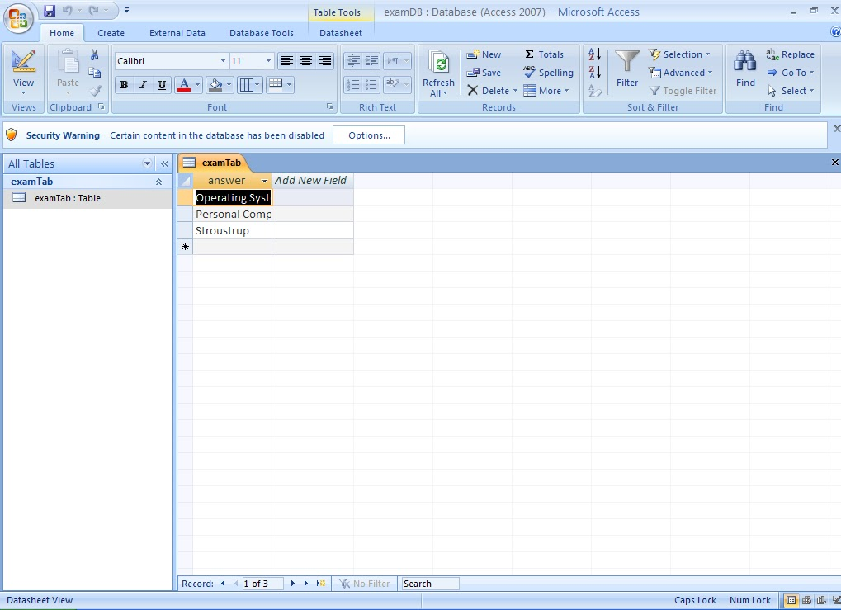

**OUTPUT**

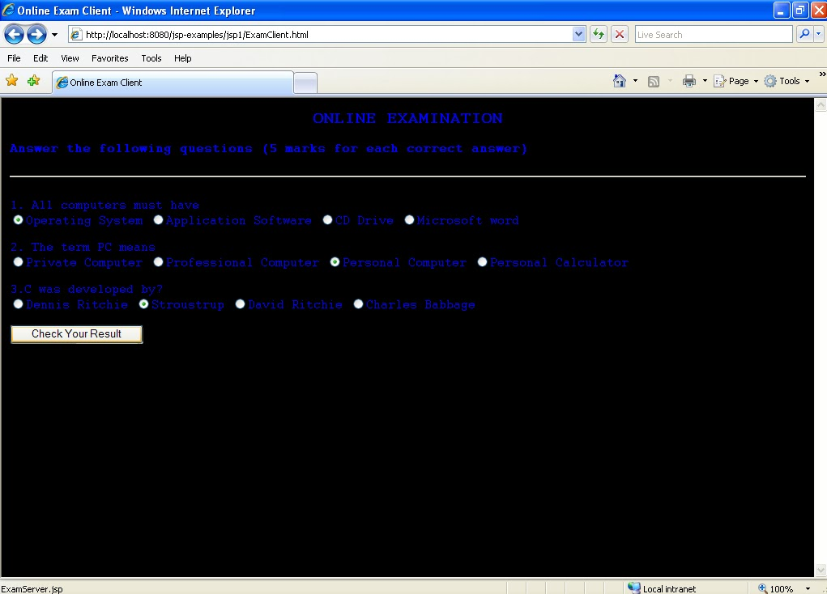

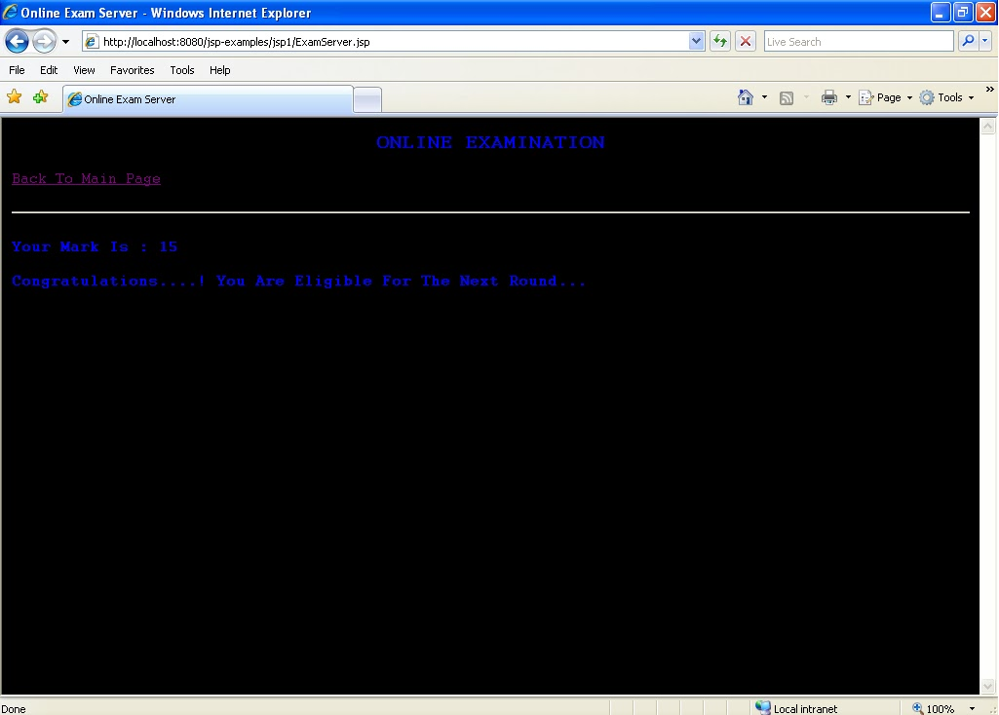

**Result:**

Thus the three tier application created for online quiz.

EX.NO : 6 Programs using XML – Schema – XSLT/XSL

**AIM:**

To write a program for implementing student information using XML & XSL.

**ALGORITHM:**

Step1:The XML document reference to the XSL document.

Step2: The create the student information in the student tag and insert the same

information about the student.

Step3:Close all opened tags.

Step4:In XSL document create a html file include the student information in table format.

Step5:Close the necessary tags.

**PROGRAM:**

//student.xml

<?xml version="1.0"?>

<?xml-stylesheet type="text/css" href="student.css"?>

<!DOCTYPE student SYSTEM "student.dtd">

<students>

<student>

<sno>801041</sno>

<sname>S.Soundarapandian</sname>

<dob>05/081991</dob>

<address>Neyveli</address>

<m1>80</m1>

<m2>90</m2>

<m3>95</m3>

</student>

<student>

<sno>801049</sno>

<sname>R.Vadivelan</sname>

<dob>22/07/1990</dob>

<address>Pondicherry</address>

<m1>90</m1>

<m2>95</m2>

<m3>80</m3>

</student>

<student>

<sno>801037</sno>

<sname>R.Satheesh</sname>

<dob>21/01/1991</dob>

<address>Kanyakumari</address>

<m1>80</m1>

<m2>90</m2>

<m3>95</m3>

</student>

</students>

//student.css

Student { background.color:#aabbcc;width:100%;} Sno {

display:block; color:GREEN; font.size:25pt; } Sname {

display:block; color:BLACK; font.size:20pt; }Dob {

display:block; color:BLUE; font.size:15pt; } Address {

display:block; color:BLUE; font.size:15pt; }m1 {

display:block; color:BLUE; font.size:15pt; }

m2 { display:block; color:BLUE; font.size:15pt; }m3 {

display:block; color:BLUE; font.size:15pt;}

//student.dtd`

<?xml version="1.0"?>

<!ELEMENT students (student+)>

<!ELEMENT student (sno,sname,dob,address,m1,m2,m3)>

<!ELEMENT sno (#PCDATA)>

<!ELEMENT sname (#PCDATA)>

<!ELEMENT dob (#PCDATA)>

<!ELEMENT address (#PCDATA)>

<!ELEMENT m1 (#PCDATA)>

<!ELEMENT m2 (#PCDATA)>

<!ELEMENT m3 (#PCDATA)>

OUTPUT:

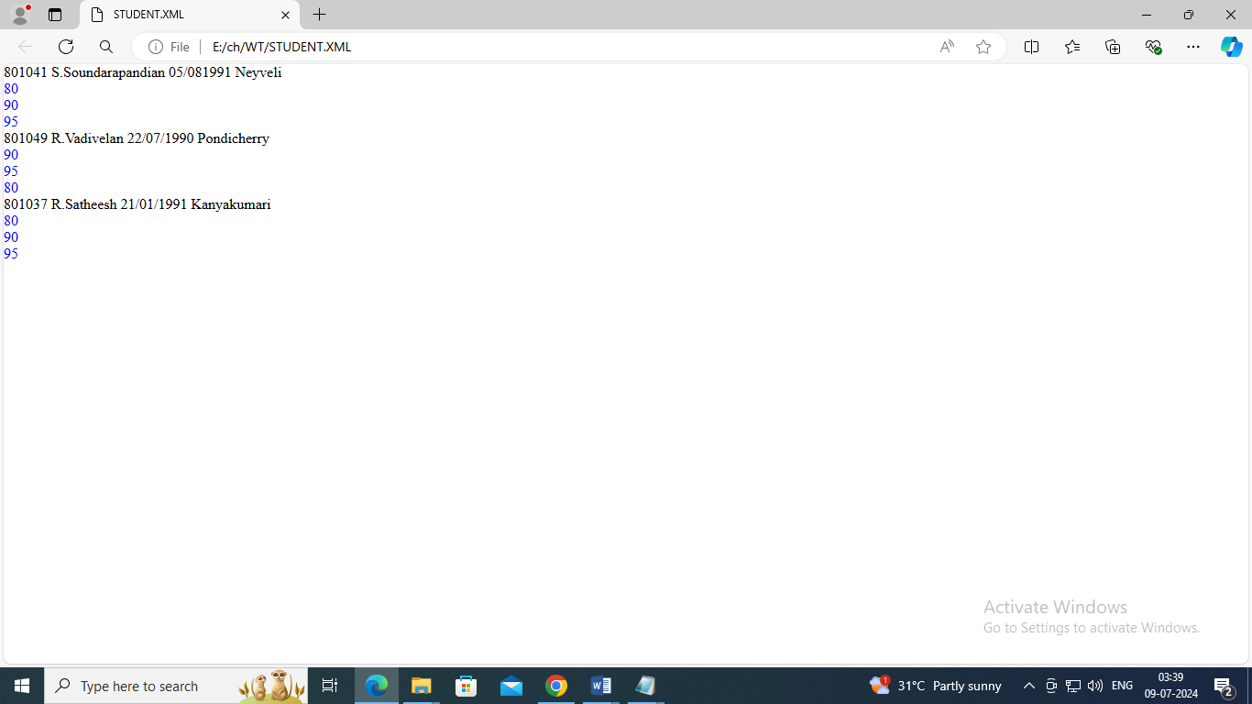

**RESULT**:

Thus the creation of XSL document using Xml has been verified successfully

**Ex 7 Programs using NoSQL**

**Aim:**

To develop programs using NoSQL –MonoDB – Create a restaurant database and display using find query.

**Algorithm:**

1. Go to the MongoDB Atlas website (https://www.mongodb.com/cloud/atlas) and

click on the "Sign up" button in the top-right corner.

2. Enter your email address and create a password. You can also sign up with your

Google or Github account.

3. Select the type of organization you're signing up for: "Personal" or "Team". If you're

signing up for a team, you'll need to provide additional information about your

organization.

4. Fill in your personal information, including your name and country.

5. Review the Terms of Service and Privacy Policy, and click on the "Create Account"

button.

6. You'll be taken to the MongoDB Atlas dashboard, where you can create your first

project. Click on the "Create a New Project" button to get started.

7. Give your project a name, select your preferred cloud provider and region, and click

on the "Create Project" button.

8. Once your project is created, you can start creating clusters and adding data to

your database.

[**Program**](https://www.w3resource.com/mongodb-exercises/mongodb-exercise-2.php)

Structure of 'restaurants' collection :

{

"address": {

"building": "1007",

"coord": [ -73.856077, 40.848447 ],

"street": "Morris Park Ave",

"zipcode": "10462"

},

"borough": "Bronx",

"cuisine": "Bakery",

"grades": [

{ "date": { "$date": 1393804800000 }, "grade": "A", "score": 2 },

{ "date": { "$date": 1378857600000 }, "grade": "A", "score": 6 },

{ "date": { "$date": 1358985600000 }, "grade": "A", "score": 10 },

{ "date": { "$date": 1322006400000 }, "grade": "A", "score": 9 },

{ "date": { "$date": 1299715200000 }, "grade": "B", "score": 14 }

],

"name": "Morris Park Bake Shop",

"restaurant_id": "30075445"

}

**Query:**

db.restaurants.find({},{"restaurant_id" : 1,"name":1,"borough":1,"cuisine" :1});

**Output:**

{ "_id" : ObjectId("564c2d939eb21ad392f175c9"), "borough" : "Manhattan", "cuisine" : "Irish", "name" : "Dj Reynolds Pub And Restaurant", "restaurant_id" : "30191841" }

{ "_id" : ObjectId("564c2d939eb21ad392f175ca"), "borough" : "Bronx", "cuisine" : "Bakery", "name" : "Morris Park Bake Shop", "restaurant_id" : "30075445" }

{ "_id" : ObjectId("564c2d939eb21ad392f175cb"), "borough" : "Brooklyn", "cuisine" : "American ", "name" : "Riviera Caterer", "restaurant_id" : "40356018" }

{ "_id" : ObjectId("564c2d939eb21ad392f175cc"), "borough" : "Brooklyn", "cuisine" : "Hamburgers", "name" : "Wendy'S", "restaurant_id" : "30112340" }

{ "_id" : ObjectId("564c2d939eb21ad392f175cd"), "borough" : "Queens", "cuisine" : "Jewish/Kosher", "name" : "Tov Kosher Kitchen", "restaurant_id" : "40356068" }

{ "_id" : ObjectId("564c2d939eb21ad392f175ce"), "borough" : "Queens", "cuisine" : "American ", "name" : "Brunos On The Boulevard", "restaurant_id" : "40356151" }

{ "_id" : ObjectId("564c2d939eb21ad392f175cf"), "borough" : "Brooklyn", "cuisine" : "American ", "name" : "Regina Caterers", "restaurant_id" : "40356649" }

{ "_id" : ObjectId("564c2d939eb21ad392f175d0"), "borough" : "Brooklyn", "cuisine" : "Delicatessen", "name" : "Wilken'S Fine Food", "restaurant_id" : "40356483" }

{ "_id" : ObjectId("564c2d939eb21ad392f175d1"), "borough" : "Bronx", "cuisine" : "American ", "name" : "Wild Asia", "restaurant_id" : "40357217" }

{ "_id" : ObjectId("564c2d939eb21ad392f175d2"), "borough" : "Brooklyn", "cuisine" : "Ice Cream, Gelato, Yogurt, Ices", "name" : "Taste The Tropics Ice Cream", "restaurant_id" : "40356731" }

{ "_id" : ObjectId("564c2d939eb21ad392f175d3"), "borough" : "Brooklyn", "cuisine" : "American ", "name" : "C & C Catering Service", "restaurant_id" : "40357437" }

{ "_id" : ObjectId("564c2d939eb21ad392f175d4"), "borough" : "Brooklyn", "cuisine" : "Chinese", "name" : "May May Kitchen", "restaurant_id" : "40358429" }

{ "_id" : ObjectId("564c2d939eb21ad392f175d5"), "borough" : "Manhattan", "cuisine" : "American ", "name" : "1 East 66Th Street Kitchen", "restaurant_id" : "40359480" }

{ "_id" : ObjectId("564c2d939eb21ad392f175d6"), "borough" : "Brooklyn", "cuisine" : "Jewish/Kosher", "name" : "Seuda Foods", "restaurant_id" : "40360045" }

{ "_id" : ObjectId("564c2d949eb21ad392f1c593"), "borough" : "Queens", "cuisine" : "Other", "name" : "Laquana King", "restaurant_id" : "50003441" }

{ "_id" : ObjectId("564c2d939eb21ad392f175d7"), "borough" : "Brooklyn", "cuisine" : "Ice Cream, Gelato, Yogurt, Ices", "name" : "Carvel Ice Cream", "restaurant_id" : "40360076" }

{ "_id" : ObjectId("564c2d939eb21ad392f175d8"), "borough" : "Queens", "cuisine" : "Ice Cream, Gelato, Yogurt, Ices", "name" : "Carvel Ice Cream", "restaurant_id" : "40361322" }

{ "_id" : ObjectId("564c2d939eb21ad392f175d9"), "borough" : "Brooklyn", "cuisine" : "Delicatessen", "name" : "Nordic Delicacies", "restaurant_id" : "40361390" }

{ "_id" : ObjectId("564c2d939eb21ad392f175da"), "borough" : "Brooklyn", "cuisine" : "American ", "name" : "The Movable Feast", "restaurant_id" : "40361606" }

{ "_id" : ObjectId("564c2d939eb21ad392f175db"), "borough" : "Manhattan", "cuisine" : "American ", "name" : "Glorious Food", "restaurant_id" : "40361521" }

**Result:**

Thus the table creation using NoSQL Database MongoDB is completed.